update ec2 instance

sudo yum -y update

Kubernetes

curl -s https://packages.cloud.google.com/apt/doc/apt-key.gpg | apt-key add -

sudo echo deb http://apt.kubernetes.io/ kubernetes-xenial main > /etc/apt/sources.list.d/kubernetes.list

sudo yum install docker.io kubectl=1.20.5-00 kubeadm=1.20.5-00 kubelet=1.20.5-00

--------------->Git install

sudo yum install git -y

install java

------------------------------------------

Java 8

sudo yum install java-1.8.0-openjdk

java -version

sudo yum remove java-1.8.0-openjdk -y

sudo alternatives --config java : This command is switch from one version to another version

sudo yum install java (current version 17)

java 11

to install java 11

sudo yum install java-21

---------------------------------------------

------------------->Jenkin

Now, to download the latest Jenkins package

-->sudo wget -O /etc/yum.repos.d/jenkins.repo https://pkg.jenkins.io/redhat/jenkins.repo

**iv. **To enable the installation of the package, import the key file from Jenkins-CI:

--->sudo rpm --import https://pkg.jenkins.io/redhat-stable/jenkins.io.key

or

sudo rpm --import https://pkg.jenkins.io/redhat-stable/jenkins.io-2023.key

Install Jenkins on the EC2 instance

---->sudo yum install jenkins

To start the Jenkins service

---->sudo service jenkins start

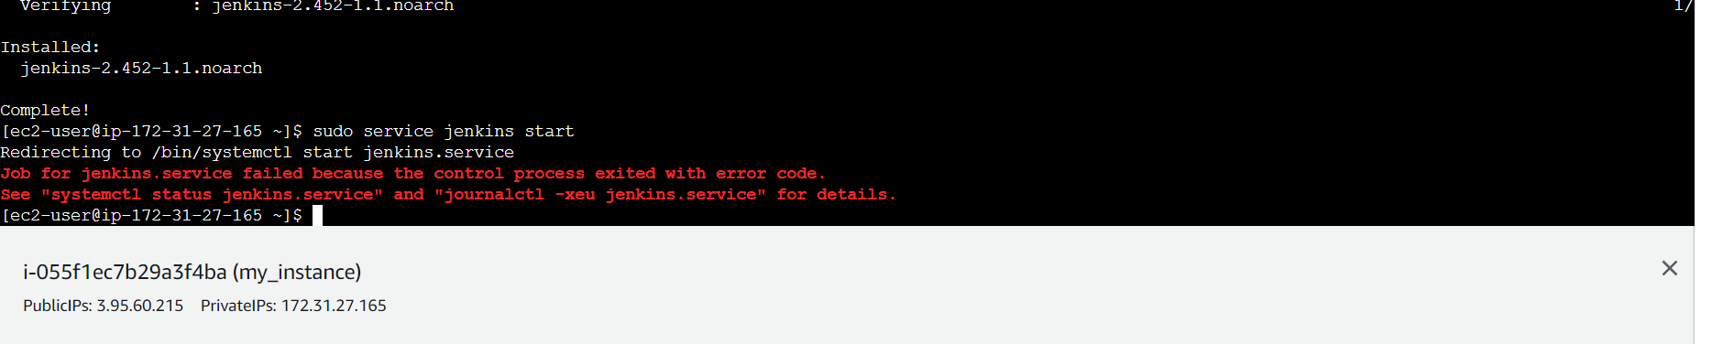

If got this error do the below step

sudo alternatives –config java

To restart the jenkin

----> sudo service jenkins restart

to check the status

-----> sudo systemctl status jenkins

This one is get the password

sudo cat /var/lib/jenkins/secrets/initialAdminPassword

to remove jenkin

sudo yum remove jenkins

to clean jenkins cache

--> rpm -ql jenkins

Or

sudo wget -O /etc/yum.repos.d/jenkins.repo https://pkg.jenkins.io/redhat/jenkins.repo

sudo rpm --import https://pkg.jenkins.io/redhat-stable/jenkins.io-2023.key

sudo yum install Jenkins

after installation we need to start the Jenkin

sudo service jenkins start this command to start

sudo systemctl status Jenkins this is use to check the status

to exit that flow please type cntr + c twice

-----------------------> Node JS

node --version

sudo yum install nodejs npm

or

install node

curl -o- https://raw.githubusercontent.com/nvm-sh/nvm/v0.34.0/install.sh | bash

or

curl -sL https://deb.nodesource.com/setup_12.x | sudo -E bash -

. ~/.nvm/nvm.sh

nvm install node (node version manager)

or

nvm install --lts

-------> Mongo DB install

sudo yum install -y mongodb-org

https://docs.mongodb.com/manual/tutorial/install-mongodb-on-amazon/ refer this documentation

sudo yum install -y mongodb-org : may be file not present

sudo vi /etc/yum.repos.d/mongodb-org-5.0.repo : this will create the file

[mongodb-org-5.0]

name=MongoDB Repository

baseurl=https://repo.mongodb.org/yum/amazon/2/mongodb-org/5.0/x86_64/

gpgcheck=1

enabled=1

gpgkey=https://www.mongodb.org/static/pgp/server-5.0.asc

cont key

:wq!

sudo yum install -y mongodb-org

to start the server

sudo systemctl start mongod

if wait to start

sudo systemctl daemon-reload

to check the status

sudo systemctl status mongod

Then to run the application

mongo

--------------Docker

install docker

sudo yum install docker

sudo service docker start

sudo docker info

sudo docker images

-------------------------------------------------

---------------------------Docker-compose -------------

Download the current stable release of Docker Compose

sudo curl -L https://github.com/docker/compose/releases/latest/download/docker-compose-$(uname -s)-$(uname -m) -o /usr/local/bin/docker-compose

Give the permission

sudo chmod +x /usr/local/bin/docker-compose

docker-compose version

Now we will create the docker service and group and usermode

sudo groupadd docker

sudo usermod -a -G docker ec2-user

-----if you want to run docker and docker-compose in jenkin then please execute these command ---------------------

sudo usermod -a -G docker jenkins

sudo usermod -a -G docker ec2-user (ec2-user is user name of instance )

sudo chmod 777 /var/run/docker.sock

sudo service jenkins restart

--------------------------------------------

ps | grep java-fullstack | awk '{print $1}' | xargs kill -9 || true

env SERVER.PORT=8081 nohup java -jar ./target/java-fullstack-1.0-SNAPSHOT.jar &